**New Biryani House**

**Author:**

**Time limit:** 2 seconds

**Memory limit:** 256 megabytes

Inspired by the successful food business of IIUC's "Kashbon," Salim Miya, a witty person, quickly grabbed the opportunity to build a biryani house beside Kashbon for the IIUCians.

He sells ***n*** types of biryani, ***ith*** type produces ***pi*** profit ***(1 <= i <= n, 1 <= pi <= 100000000)***.

However, Salim Miya does not receive the entire profit amount from each biryani type. Because when he initially set up the biryani house, instead of directly purchasing a large room, he made a deal with the room owner. According to the agreement, Salim Miya keeps an amount ***x*** from the profit of each biryani type, and the remaining amount is given to the room owner. This arrangement ensures that the room owner receives at least a total of ***m*** money.

Salim Miya aims to maximize the value of ***x***. By doing so, he can increase his own earnings while ensuring that the room owner's condition is met. Your task is to assist Salim Miya in determining the optimal value of ***x***.

The calculation of the first testcase is given below:

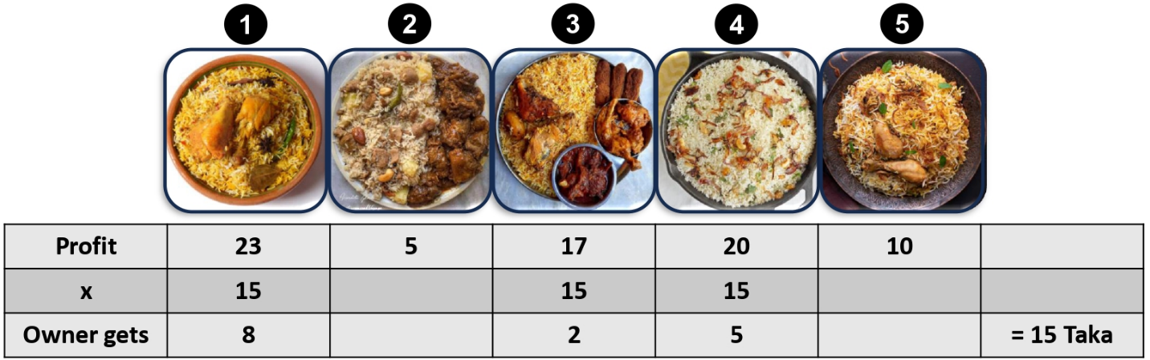

**Input:**

The input consists of two lines:

* The first line contains two space-separated integers, ***n*** and ***m***, representing the number of biryani types ***(1 <= n <= 1000000)*** and the minimum total amount the room owner should receive ***(1 <= m <= 2000000000)***.
* The second line contains ***n*** space-separated positive integers less than ***1000000000***, the profit of each type of biryani. The sum of all profits will exceed ***m***, thus the owner will always be able to obtain the required amount of money.

**Output**

The output consists of a single integer, which is the maximum value of ***x*** that satisfies the given conditions.

**Examples**

|  |  |
| --- | --- |
| **Input** | **Output** |
| **5 14**  **23 5 17 20 10** | **15** |
| **4 26**  **6 3 8 12** | **0** |
| **6 20**  **50 12 27 9 14 2** | **30** |